User Guide

## Background:

<Insert here the background on your product, what the main goal of your product, what do you want the user to know from the first glance>

The document is a user guide to educate the user to know how to operate the product . This documents provides information on how to use the product for the end user and for the support team for triaging the issue and contacting the team for any issues,

## Details:

The high level architecture of the Doordash delivery system is depicted below :

Mobile App and backend

Robot Delivery and re-routing

The main features of the product are :

1. Mobile app and the backend : The mobile app helps the user to login and order the food. The order is the recorded in the database of the Doordash delivery system’s database, the notification is sent to the user about the order placed and the estimated time of delivery.

The user logs in with his credentials using login page of the Doordash mobile app as shown in the below figure

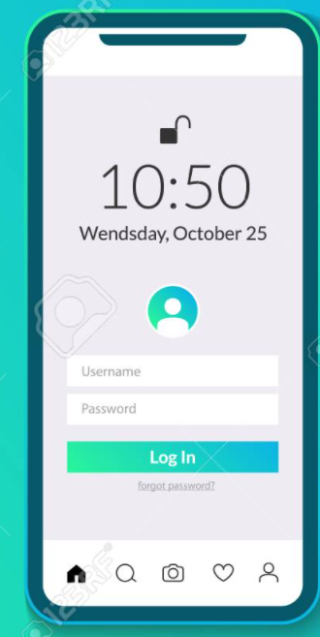

There is a recovery option of username and password, where in the user can click the forgot password option.

1. Doordash delivery system : The Doordash delivery system is the backend and all the business logic is implement in this platform. The Doordash delivery system provides the Realtime tracking, re-routing and notification features. The operations team members have access to this back-end system which has the privileges to interact with the Dashdoor robot in real time and can re-route it if there is a request from the user to do so. Also, the Doordash has built in analytics engine for the analysis of the orders received and the management make informed decisions or change strategy based on the outcome.

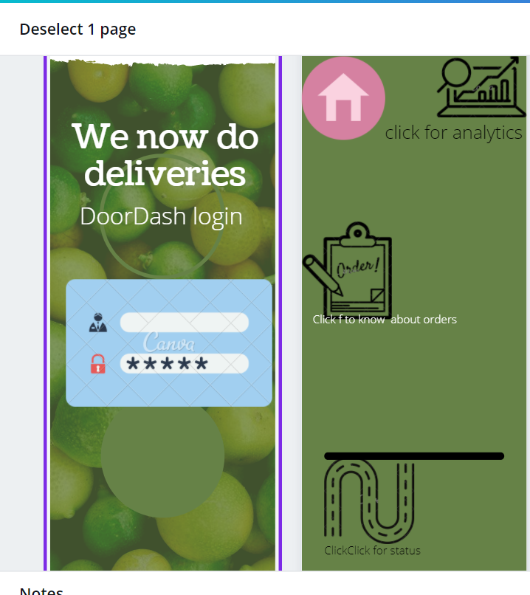

The above figure is the backend of the Dashdoor for the operation team and the customers, it has icons to know the status of the robot, analytics and robot tracking with click of respective icons.

1. Robot delivery and re-routing

<Insert here details on how to user 3 of your main features>

<Feature Name (user-facing name)>:

* Describe the main functionality of that feature.
* Describe how users can get to your feature
* Describe any known issues with the product (or upcoming features)
* Show at least one visual element (screenshot or mock)

*Note: if you have screenshots/mocks for different states of the feature, integrate these into the feature description. Visual elements are very helpful for the user to understand your product*